CURRICULUM VITAE
PABITRO DASMALI
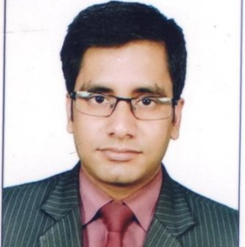
Address:
Chinar Park,
Rajarhat
Kolkata -700136
West Bengal
MOB No: 8013880675
E-mail ID: feelpabitro@gmail.com

CAREER OBJECTIVE:

I am seeking a position to utilize my skills and ability in the industry that offers professional growth while being resourceful, innovative and flexible. I want to grow up as a person of Experience, Sincerity and Maturity.
Experience:

Organization | Designation | Tenure | Work Profile
Geetanjali Resorts and Hotels Pvt Ltd. | HR Executive | 1st Sep 2015 to till Now | - Salary Sheet Preparation  - Attendance record preparation  - Appointment Letter Preparation  - Maintaining Leave Record  - Preparation Of Monthly Biometric finger Print Report  - Interview Tacking  - P. F  - E.S.I  - P. Tax  - Gratuity  - Recruitment  - Job Portal Handling  - Job Posting  - Mass Mailing & Calling the Candidates  - Preparing Offer letter
Desun Hospital | HR Assistant | 1st Oct 2011 to 31st March 2013. | - Maintain Employees File  - Daily Attendance Report Preparation  - Appointment Letter Preparation  - Conducting Training  - Updating Training Record  - Allotting Locker to all Staff  - Helping in Salary Preparation  - Maintaining Leave Record  - Preparing Experience Certificate

CERTIICATION:

- The HR Generalist and Recruitment Training Programme from Corp Bounty.
- Two Years Diploma on Computer Application.

EDUCATION QUALIFICATION:

Professional Qualification:

Stream | University / College | Year of Passing | Percentage
MBA(HR) | Gulbarga University  (IBSM) | 2015 | 73%
Hospital Management | WBUT | 2011 | 83.4%
Academic Qualification:
Exam | Year of Passing | Board/ Council | Percentage
HS | 2006 | WBCHSE | 71%
Madhymik | 2004 | WBBSE | 69%
MY STRENGTH:

- My ability to work in team.
- My positive attitude to work.
- My problem-solving skills.
- Punctuality
TECHNICAL SKILL:
- Computer Application ( 2 Years HS Degree Course)
- IDS Hotel Software
PERSONAL PROFILE:
Date of Birth :28th Dec 1988
Sex :Male
Hobbies :Playing Guitar, Reading Books, Listening Music, Surfing Internet&
Painting.
Marital status : Unmarried
Languages Known :English, Bengali and Hindi.

Declaration
I, hereby declare that all the statements made in the above applications are true and correct to the best of my knowledge and belief.

Place: ------------------------------ Date: Signature

